**Gas Leakage Monitoring and Alerting**

**System for Industries**

**TEAM MEMBER:** NISHMITHA K R,

PURUSHOTHAMAN K,

RAGU M,

SANGEETH G

**TEAM ID :** PNT2022TMID07369

**DEPARTMENT OF ELECTRONICS AND COMMUNICATION**

**ENGINEERING**

**1. INTRODUCTION**

**1.1 Project Overview:**

In today's world, safety is of the utmost importance, and certain measures must be taken at both work and home to e ensure it. Working or living in a dangerous environment necessitates specific safety measures, whether the subject is electricity or oil and gas. A type of natural gas known as "Liquified Petroleum Gas" (LPG) is compressed under high pressure and stored in a metal cylinder. LPG is extremely vulnerable to fire and can result in catastrophic damage if left unprotected near any fire source. LPG is primarily utilized for cooking and is more readily available than any other natural gas. Sadly, its widespread use makes gas leakage or even a blast a common occurrence. As a result, a system for detecting and monitoring gas leaks is required. Through a flame sensor, the system will keep an eye on fire and flame. The buzzer begins to ring when a fire is detected. Tests have shown that the system can keep track of the wastage of gas and leaks and notify the user. The performance that was produced showed that it was successful in reducing the amount of domestic gas that was wasted.

**1.2 Purpose:**

Nowadays the home safety detection system plays an important role in the security of people. Since all the people from the home goes to work on a daily bases, it makes it impossible to check on the appliances available at home especially LPG gas cylinder, wired circuits, Etc. In the last three years, there is a tremendous hike in the demand for liquefied petroleum gas (LPG) and natural gas. To meet this access amount of demand for energy and replace oil or coal due to their environmental disadvantage, LPG and natural gas are preferred. These gases are mostly used on a large scale in industry, as heating, home appliances, and motor fuel. To monitor this gas leak, the system includes an MQ6 gas detector. This sensor detects the amount of leaking gas present in the surrounding atmosphere. In this way, the consequences of an explosion or gas leak can be avoided.

**2. LITERATURE SURVEY**

**2.1 Existing Problem:**

The Internet of Things aims towards making life simpler by automating every small task around us. As much as IoT helps in automating tasks, the benefits of IoT can also be extended to enhancing the existing safety standards. Safety, the elementary concern of any project, has not been left untouched by IoT. Gas Leakages in open or closed areas can prove to be dangerous and lethal. The traditional Gas Leakage Detector Systems though have great precision, fail to acknowledge a few factors in the field of alerting people about the leakage. Therefore, we have used IoT technology to make a Gas Leakage Detector for society which has Smart Alerting techniques involving sending a text message to the concerned authority and the ability to perform data analytics on sensor readings. Our main aim is to propose a gas leakage system for a society where each flat has gas leakage detector hardware. This will detect the harmful gases in the environment and alerting to society members through the alarm and sending notifications.

**2.2 References:**

Prof. M.Amsaveni, A.Anurupa, R.S.Anu Preetha, C.Malarvizhi, M.Gunasekaran; they told in their research paper on “GSM-based LPG leakage detection and controlling system” the leakage of LPG gas is detected by the MQ-6 gas sensor. Its analog output is given to the microcontroller. It consists of a predefined instruction set. Based on this, the exhaust fan is switched on. So, the concentration of gas inside the room gets decreased. Then, the stepper motor is rotated thus closing the knob of the cylinder. Because of this process, the leakage of gas is stopped. The relay is switched to off the power supply of the house. The buzzer produces an alarm to indicate the gas leakage. Then, the user is alerted by SMS through the GSM module. They proposed their methodology that the system takes an automatic control action after the detection of 0.001% of LPG leakage. This automatic control action provides a mechanical handle for closing the valve. We are increasing the security for humans by means of a relay which will shut down the electric power to the house. Also, by using GSM, we are sending an alert message to the users and a buzzer is provided for alerting the neighbors about the leakage.

P.Meenakshi Vidya, S.Abinaya, G.Geetha Rajeswari, N.Guna, “Automatic LPG detection and hazard controlling “ published in April 2014 proposed the leakage detection and real-time gas monitoring system. In this system, the gas leakage is detected and controlled by means of the exhaust fan. The level of LPG in the cylinder is also continuously monitored.

Srinivasan, Leela, Jeya bharathi, Kirthik,Rajasree; in this research paper they told about gas leakage detection and control. In this paper, the gas leakage resulting in fatal inferno has become a serious problem in households and other areas where household gas is handled and used. It alerts the subscriber through the alarm and the status display besides turning off the gas supply valve as a primary safety measure.

Hitendra Rawat, Ashish Kushwah, Khyati Asthana, Akanksha Shivhare, in the year 2014 planned a framework, they gave security issues against hoodlums, spillage, and fire mishaps. In those cases, their framework sends an SMS to the crisis number given to it

B. B. Did paye, Prof. S. K. Nanda; in this paper, they talked about their research on leakage detection and review of “Automated unified system for LPG using microcontroller and GSM module”. Their paper proposed an advance and innovative approach for LPG leakage detection, prevention, and automatic booking for a refill. In advance, the system provides the automatic control of the LPG regulator also if leakage is detected the system will automatically turn off the main switch of the power supply. Hence it helps to avoid explosions and blasts.

Pal-Stefan Murvaya, Ioan Sileaa, 2008, they told in their survey on gas leak detection and localization techniques various ways to detect gas leakage. They introduce some old or new techniques to detect the gas. The proposed techniques in this paper are nontechnical methods and hardware-based methods which include acoustic methods, optical methods, and active methods. In their survey they told a wide variety of leak-detecting techniques is available for gas pipelines

**2.3 Problem Statement Definition:**





|  |  |  |  |  |  |
| --- | --- | --- | --- | --- | --- |
| **Problem**  **Statement**  **(PS)** | **I am**  **(Customer)** | **I am trying to** | **But** | **Because** | **Which makes me feel** |
| PS-1 | Industrialist | Monitor gas leakage in the industry | I have no efficient system for monitoring | High cost and  Complicated process of  Installing | Disappointed |
| PS-2 | Industrialist | Control the gas leakage | Also, the installation process is too complicated | The number of sensors is unpredictable and the positioning of equipment is improper | Frustrated |

**3. IDEATION & PROPOSED SOLUTION:**

**3.1 Empathy Map Canvas:**

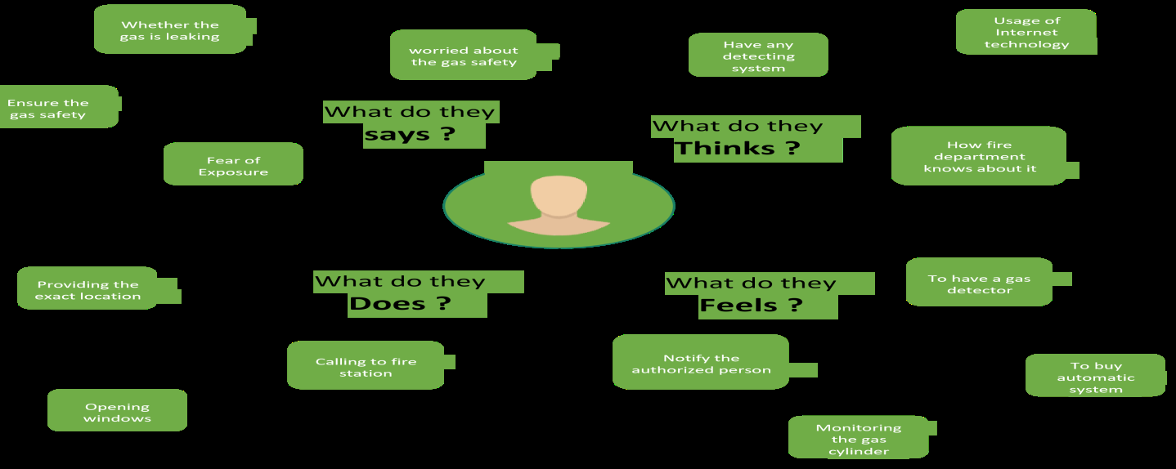

**3.2 Ideation & Brainstorming:**

The Internet of Things aims towards making life simpler by automating every small task around us. As much as IoT helps in automating tasks, the benefits of IoT can also be extended to enhancing the existing safety standards. Safety has always been an important criterion while designing a home, buildings, industries as well as cities. The increased concentration of certain gases in the atmosphere can prove to be extremely dangerous. These gases might be flammable at certain temperature and humidity conditions, toxic after exceeding the specified concentrations limits, or even a contributing factor in the air pollution of an area leading to problems such as smog and reduced visibility which can in turn cause severe accidents and have an adverse effect on the health of people. Most societies have a fire safety mechanism. But it can use after the fire exists. In order to have control over such conditions we proposed a system that uses sensors that can detect the gases such as LPG, CO2, CO, and CH4. This system will not only able to detect the leakage of gas but also alert through audible alarms. The presence of excess amounts of harmful gases in the environment then this system can notify the user. The system can notify to society admin about the condition before a mishap takes place through a message. The system consists of gas detector sensors, an Arduino board, ESP8266, and a Cloud server. One Society authority person can register the all-flat member user to our system. Society admin can add the details of per flat user such as user name, mobile number, and per-user flat sensor details information. Society admin can configure the threshold value of each sensor. System hardware can be deployed on each flat. Sensors can sense the value per time. The system can send the values to the cloud server. The server can Check that the sensor values existed in the threshold value. If the sensor value can cross the limit the server can send the command to the hardware for buzzing the alarm. The server also sends the notification message to the user.

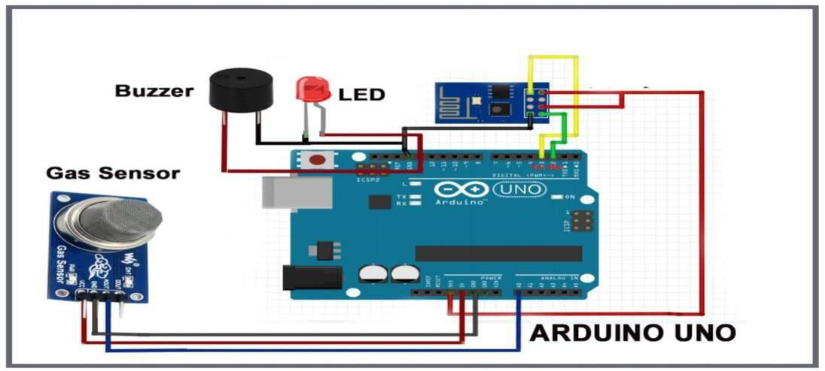In this paper, we use IOT technology for enhancing the existing safety standards. While making this prototype has been to bring a revolution in the field of safety against the leakage of harmful and toxic gases in the environment and hence nullify any major or minor hazard being caused due to them.

**3.3 Proposed Solution:**

|  |  |  |
| --- | --- | --- |
| **S.No** | **Parameter** | **Description** |
| 1. | Problem Statement  (Problem to be solved) | o Gas Leakage Monitoring and Alerting System. |
| 2. | Idea / Solution description | o Using a variety of sensor, the environmental parameters such as concentration of the gas can be monitored in real time  o If the concentration of gas reaches hazardous level an alert message can be sent to the user. |
| 3. | Novelty / Uniqueness | o Device being developed can monitor a wide range of gases that are highly used in industries. o Apart from notifying the user, Safety personnel are also notified in case of emergencies.  o User friendly in nature. |
| 4. | Social Impact /  Customer Satisfaction | o As the device is small, it is easy to install them in various locations based on necessity. |
| 5. | Business Model (Revenue Model) | o Device can be obtained by paying for the subscription.  o It can be yearly or monthly.  o Based on the term of subscription 5 – 8% discount shall be made available |
| 6. | Scalability of the Solution | o In future more variety of gas can also be monitored, by adding the necessary sensor and monitoring the data obtained from it. |

**3.4 Problem Solution fit:**

|  |  |
| --- | --- |
| 1. CUSTOMER SEGMENT(S)  •Industrialists  •Engineers  •Safety Control Personals | 2. JOBS-TO-BE-DONE / PROBLEMS  •Capability of the device to withstand a harsh environment is questionable.  •Due to network issues data could not be always uploaded to the cloud. |
| 3. TRIGGERS  •Usage of the device is portrayed in the news.  •In real-life situations, the device has helped in saving several individuals. | 4. EMOTIONS: BEFORE/AFTER  •Before the action is taken, the user feels deceived and cheated.  •After the problem is resolved, the user feels the sincerity of the developers. |
| 5. AVAILABLE SOLUTIONS  •Upgrading to a premium network plan.  •Availing of network connection from a reliable Service provider | 6. CUSTOMER CONSTRAINTS  •Network Connection  Complexity in Installation |
| 7. BEHAVIOUR  •Harsh environment is prevailing only in the certain industry; thus, the frequency of the said problem is low. In such a case the customer complains multiple times to get attention.  •Network issue is very common as most of the industries are in the countryside. Here the contact both the developers and the service providers. | 8. CHANNELS OF BEHAVIOUR  8.1 ONLINE  •E-Mail to developers  •Online Community  8.2 OFFLINE  •Complaint Letters. |
| 9. PROBLEM ROOT CAUSE  •Quality of the material using which the device is made up of  plays a vital role in the capability of the device to work in harsh environments.  •Location of the device installation and the network plan used by the user is the cause of the Network issue. | 10. YOUR SOLUTION  •Network strength must be boosted in the device  •Device can be manufactured with multiple standards based on the environment. |

**4. REQUIREMENT ANALYSIS**

**4.1 Functional requirement:**

Arduino UNO is the main unit of the system which performs the following tasks. Signal conditioning of the Arduino UNO is done by the output signal of the sensor, provided input to Arduino. The detection results are displayed on LCD. Indicates the people of danger in the workplace, factory, and home. Buzzer activity with a beep(siren) sound is made. Also, send alert SMS to the in charge of the plant whose number is saved in a SIM card by using a GSM modem. The SMS received depends upon the leak of gas in the detection area of the sensor.

**4.2 Non-Functional requirements:**

**Data Gathering:**

Using multiple sensors, we are going to gather the necessary data.

**Data Store:**

Collected data is stored in Cloud and Necessary databases.

**Data Analysis:**

Data from the store must be analyzed for raising alerts in case of necessity.

**Data Monitoring:**

Gathered data must be displayed to the user for monitoring.

**5. PROJECT DESIGN**

**5.1 Data Flow Diagrams:**

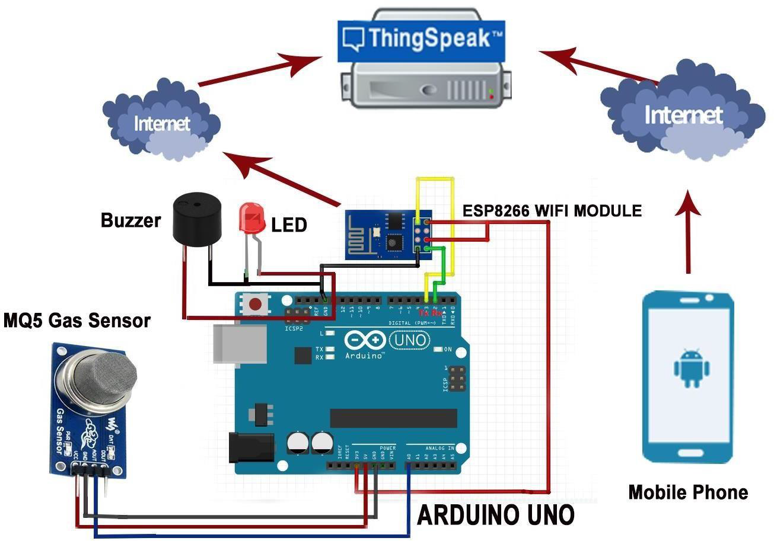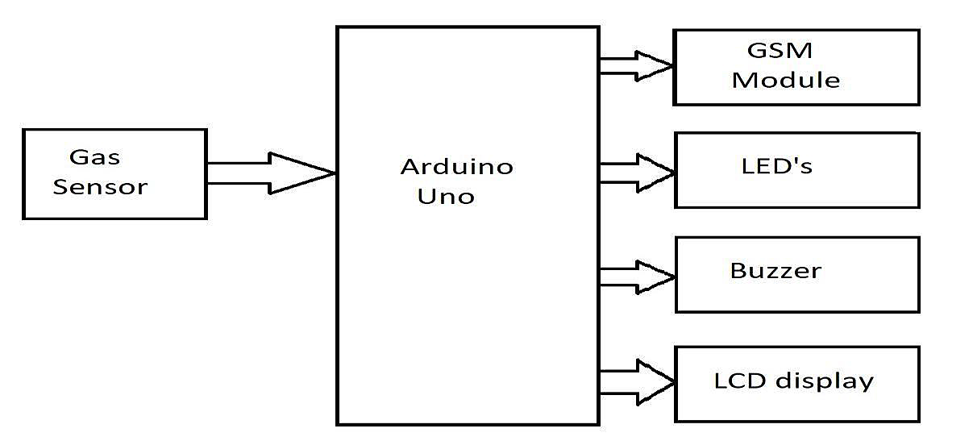**5.2 Solution & Technical Architecture:**

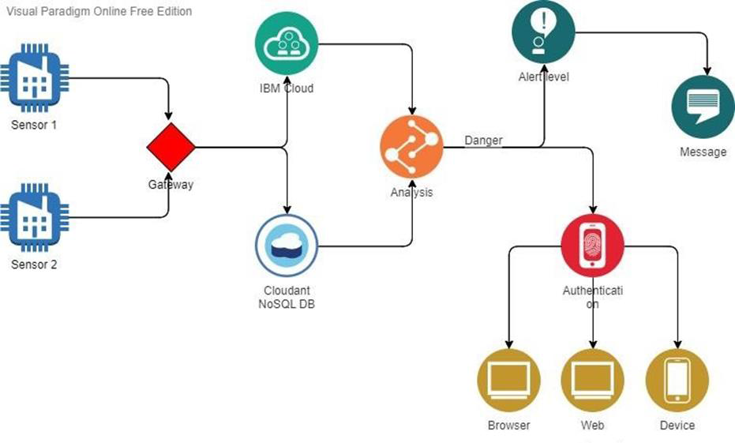

**5.3 User Stories:**

The system can be taken as a small attempt in connecting the existing primary gas detection methods to a mobile platform integrated with IoT platforms. The gases are sensed in an area of a 1m radius of the rover and the sensor output data are continuously transferred to the local server. The accuracy of sensors is not up to the mark thus stray gases are also detected which creates an amount of error in the outputs of the

sensors, especially in the case of methane. Further, the availability and storage of toxic gases like hydrogen sulfide also create problems for testing the assembled hardware. As the system operates outside the pipeline, the complication of system maintenance and material selection of the system in case of corrosive gases is reduced. Thus, the system at this stage can only be used as a primary indicator of leakage inside a plant.

**6. PROJECT PLANNING & SCHEDULING**

**6.1 Sprint Planning & Estimation:**

• SPRINT PLAN

• ANALYZE THE PROBLEM

• PREPARE An ABSTRACT, PROBLEM STATEMENT

• LIST A REQUIRED OBJECT NEEDED

• CREATE A PROGRAM CODE AND RUN IT

• MAKE A PROTOTYPE TO IMPLEMENT

• TEST WITH THE CREATED CODE AND CHECK THE DESIGNED PROTOTYPE IS

**6.2 Sprint Delivery Schedule**

• Sprint 1

• Sprint 2

• Sprint 3

• Sprint 4

We are Developing the code in this Schedule.

**7. Schematic Diagram of project & Components:**

**7.1 Circuit Diagram:**

z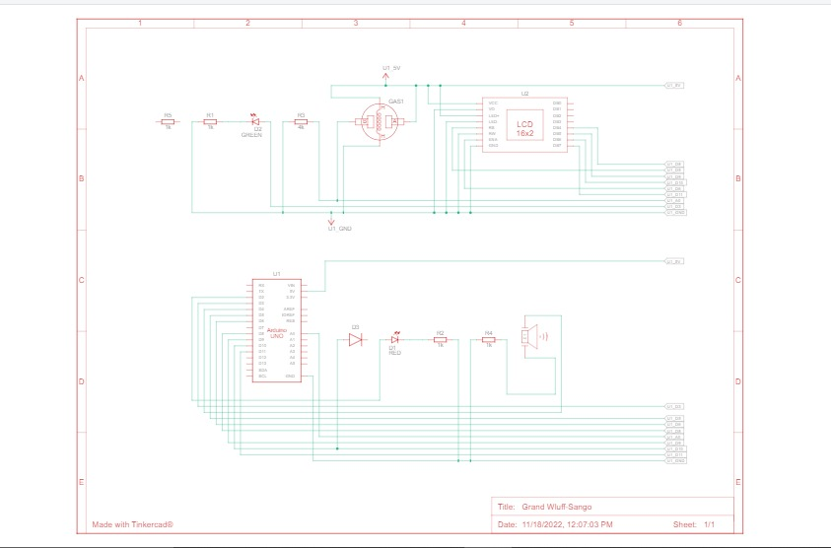

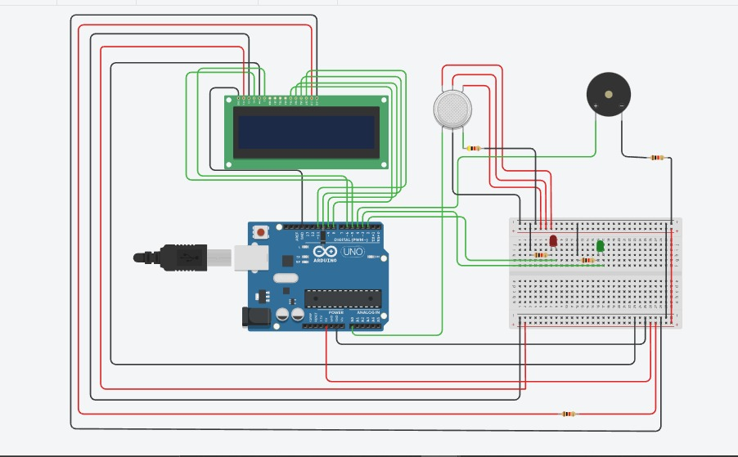

**7.2 Components:**

The design of a sensor-based automatic gas leakage detector with an alert and control system. The components are

|  |  |  |
| --- | --- | --- |
| **S. No.** | **Name of the Component** | **Quantity** |
| 1. | Arduino UNO R3 | 1 |
| 2. | Breadboard | 1 |
| 3. | LED | 2 |
| 4. | Resistor | 5 |
| 5. | Piezo | 1 |
| 6. | Gas Sensor | 1 |
| 7. | LCD (16x2) | 1 |

**8. CONCLUSION:**

After this project performance can conclude that the detection of the LPG gas leakage is incredible in the project system. Applicable usefully for industrial and domestic purposes. In dangerous situations, we can save the life by using this system. An alert is indicated by the GSM module. A sensor node senses gas like CO2, oxygen, and propane. The estimated range of transmission and consumption of power is obtained. The simple procedures and Arduino UNO Micro controller area used to build the sensor.

**9. FUTURE SCOPE:**

We propose to build the system using an MQ6 gas detection sensor and interface it with an Aurdino Uno microcontroller along with an LCD Display.

Our system uses the gas sensor to detect any gas leakages. The gas sensor sends out a signal to the microcontroller as soon as it encounters a gas leakage. The microcontroller processes this signal and a message is displayed on the LCD to alert the user.

**10. APPENDIX:**

**Source Code:**

#include <LiquidCrystal.h>

LiquidCrystal lcd(5,6,8,9,10,11);

int redled = 2;

int greenled = 3;

int buzzer = 4;

int sensor = A0;

int sensorThresh = 400;

void setup()

{

pinMode(redled, OUTPUT);

pinMode(greenled,OUTPUT);

pinMode(buzzer,OUTPUT);

pinMode(sensor,INPUT);

Serial.begin(9600);

lcd.begin(16,2);

}

void loop()

{

int analogValue = analogRead(sensor);

Serial.print(analogValue);

if(analogValue>sensorThresh) {

digitalWrite(redled,HIGH);

digitalWrite(greenled,LOW);

tone(buzzer,1000,10000);

lcd.clear();

lcd.setCursor(0,1);

lcd.print("ALERT");

delay(1000);

lcd.clear();

lcd.setCursor(0,1);

lcd.print("EVACUATE");

delay(1000);

}

else

{

digitalWrite(greenled,HIGH);

digitalWrite(redled,LOW);

noTone(buzzer);

lcd.clear();

lcd.setCursor(0,0);

lcd.print("SAFE");

delay(1000);

lcd.clear();

lcd.setCursor(0,1);

lcd.print("ALL CLEAR");

delay(1000); }

}

**GitHub & Project Demo Link:**

**Tinkercad link:<https://www.tinkercad.com/things/2odNr2VN32n-grand-wluff-sango/editel?tenant=circuits>**

**Github Link:<https://github.com/IBM-EPBL/IBM-Project-29062-1660120513>**

**Video link:https:<https://photos.app.goo.gl/XE9MSmZnqdhHGz1X8>**